Front-End Technologies Basics Regular Exam

DOM Manipulation
Use the provided skeleton to solve this problem.
Write the missing functionality of this user interface.

Application structure
You are provided with an HTML application - Smoothie Order System with the following structure:
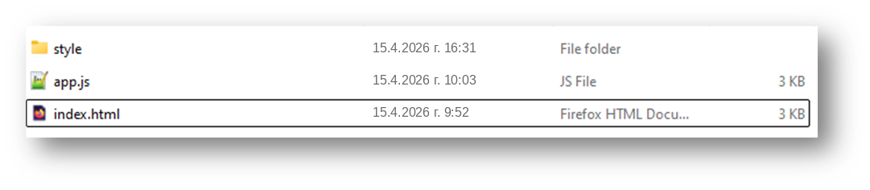

Open the index.html to start the application. Its purpose is to order smoothies. The application looks like this:
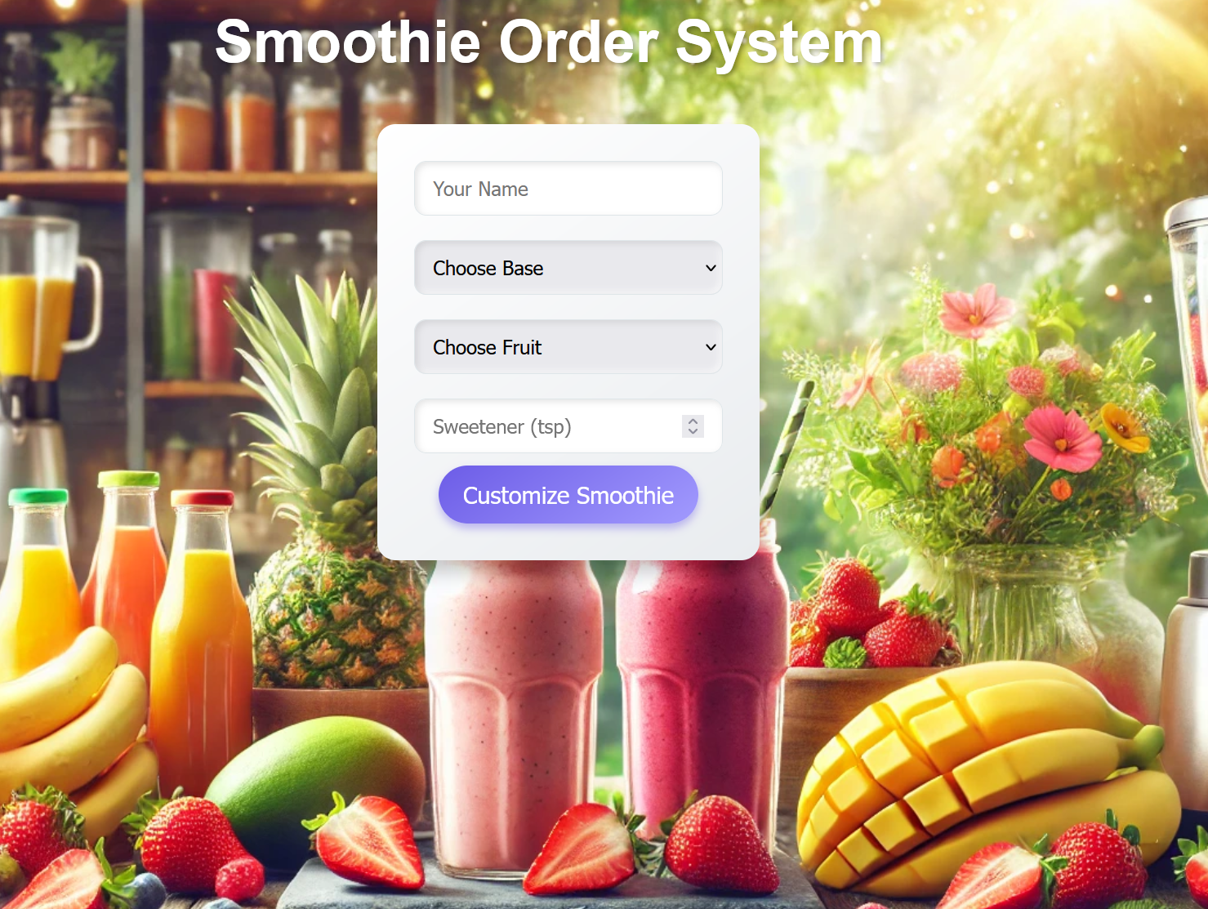

Look at the html structure in the index.html file. You will notice that there are 2 hidden elements:

The preview element is supposed to be displayed after the 'Customize Smoothie' button is clicked. The element with id="order-success" is supposed to be displayed after the order is finalized.

Your Task
Write the missing JavaScript code in the app.js file to make the Smoothie Order System work as expected:

Customize Smoothie Button Functionality
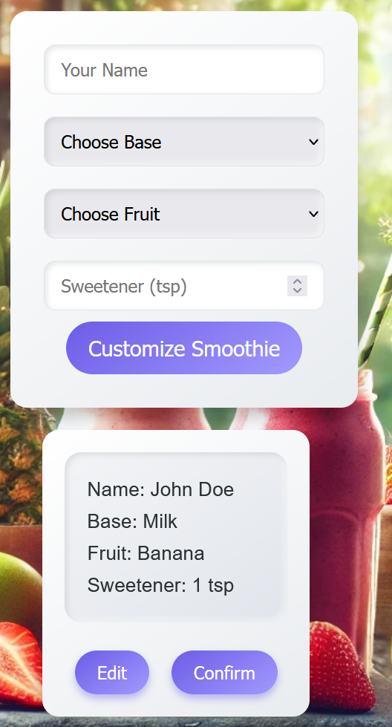

When the [Customize Smoothie] button is clicked, you need to validate that all fields are filled. If this is not the case, do not proceed.

Do NOT include any additional validation for the fields.

If the validation is successful, the following functionality needs to be implemented:
- The information about the smoothie is filled in the preview element – name, base, fruit, sweetener.
- The preview element must be displayed.
- The 'Customize Smoothie' button must be disabled.
- The values of the fields in the form must be cleared.

Edit Smoothie Info
When the [Edit] button is clicked, all of the information is loaded back into the input fields from step 1, while the [Customize Smoothie] button is enabled again.
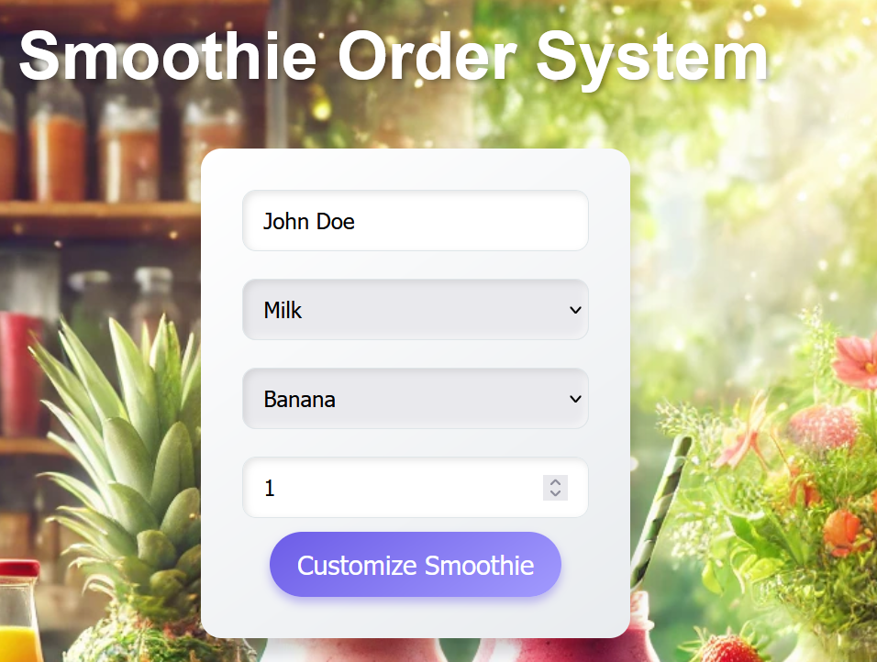
The preview element must be hidden.

Confirm Smoothie
When the [Confirm] button is clicked, you must hide the preview element and show the element with id="order-success".
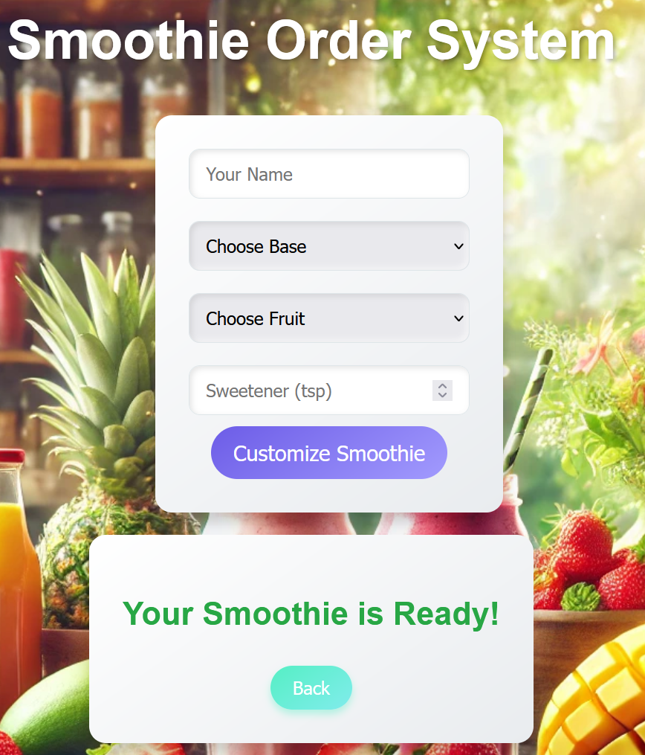

Back
When the [Back] button is clicked, you must hide the element with id="order-success and enable the [Customize Smoothie] button.

JS Application Testing
You have been given a JavaScript application. All the necessary setup is complete, allowing you to start writing your tests. Your goal is to write end-to-end (Front-End) tests using Playwright.

App Introduction
The application for testing is called "Recipe Sharing Hub". It's a user-friendly application offering functionalities and permissions based on user login status:

- For guest user:
- Home Page: View a brief introduction to the app.
- Discover page: See all created recipes.
- Search Page: Search for recipes by name.
- Register/Login page: Register a new account or log in.
- For Logged-In user:
- Create Recipe Page: Create new recipes.
- Discover: See all created recipes (both your own and others').
- Search Page: Search for recipes by name.
- Logout: Log out of the app.
- Recipe details functionality:
- Detail View: Only logged-in users can see detailed information about a recipe.
- Edit/Delete Buttons: Only the owner of a recipe can see and use the Edit and Delete buttons in the detail view to modify or remove the recipe.
- Navigation bar: Provides easy access to application functionalities based on your login status (logged in or guest).

Also, there will be seeded data for 3 recipes, that will always be loaded when you start the application.

Instructions

A folder named "tests" is prepared for you. There is a single file named "e2e.test.js". In it, you must write your front-end tests with the Playwright framework.

As for the execution of the tests, you need to start the back-end server of the application and the HTTP server. Everything is configured for you, so you need just to execute three commands in two terminals:
- "npm install" (or "npm i ") – to install the dependencies for your app.
- "npm run server" – to start the application back-end server.
- "npm start" (in another terminal) – to start the HTTP server.
- "npm test" – to run Playwright tests

Note: You will need to use a third Terminal window for the execution of Playwright tests.

Front-End Testing with Playwright

You are provided with predefined configurations in the e2e.test.js file:
- Needed imports for Playwright:

- Predefined variables that you can use:
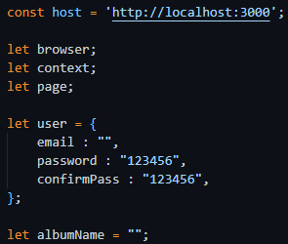

- Before and after test configurations:
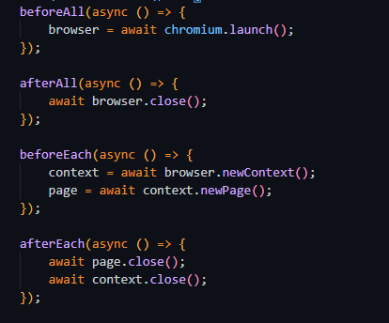

- Test suits:
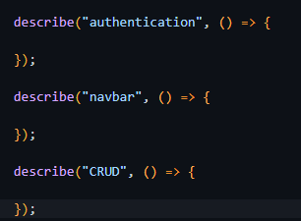
Use them and write the following e2e tests with Playwright for the "Recipe Sharing Hub" application.

IMPORTANT: You are NOT allowed to delete nor add any test, use the tests exactly as they are provided.
NOTE: The tests are dependent on each other, so you should run them all together.

Registration with Valid Data (Authentication Functionality)

- Create a test scope.
- Go to http://localhost:3000
- Locate and click on the Register button.
- Wait for the register form to load.
- Create a unique email value.
- Locate and fill the input field for email.
- Locate and fill the input field for password.
- Locate and fill the input field for confirm password.
- Press the submit button.
- Assert that you are redirected to the home page and the Logout button is visible.

Hint: Use the predefined user object to hold and reuse user data.

Login with Valid Data (Authentication Functionality)

- Create a test scope.
- Go to http://localhost:3000
- Locate and click on the Login button.
- Wait for the login form to load.
- Locate and fill the input field for email.
- Locate and fill the input field for password.
- Press the submit button.
- Assert that you are redirected to the home page and the Logout button is visible.

Logout from the Application (Authentication Functionality)

- Create a test scope.
- Go to http://localhost:3000
- Log in to the application.
- Click the Logout button.
- Assert that the Login button is visible.
- Assert that the URL is for home page.

Navigation for Logged-In User Testing

- Create a test scope.
- Go to http://localhost:3000
- Log in to the application.
- Assert that "Home", "Discover", "Search", "Create Recipe" and "Logout" buttons are visible, and "Login" and "Register" buttons are hidden.

Navigation for Guest User Testing

- Create a test scope.
- Go to http://localhost:3000
- Assert that "Home", " Discover", "Search", "Login" and "Register" buttons are visible, and "Create Recipe" and "Logout" buttons are hidden.

Create a Recipe Testing (CRUD Functionality)

- Create a test scope.
- Go to http://localhost:3000
- Log in to the application.
- Locate and click the "Create Recipe" button.
- Wait for the create recipe form to load.
- Generate random recipe name and save it in predefined variable.
- Locate and fill the input field for name with random generated value.
- Locate and fill the input field for recipe image.
- Locate and fill the input field for preparation time.
- Locate and fill the input field for shared by.
- Locate and fill the input field for cuisine type.
- Locate and fill the input field for steps.
- Press the submit button.
- Assert that the url is http://localhost:3000/discover.
- Assert that a recipe with the name you just added is present in the list.

Edit a Recipe Testing (CRUD Functionality)

- Create a test scope.
- Go to http://localhost:3000
- Log in to the application.
- Locate and click on "Search" button.
- Locate and fill the input field for search. (Search for the recipe that you created)
- Locate and click on "Search" button for searching result.
- Locate and click on the name of the recipe that you created from the results.
- Locate and click on Edit button.
- Wait for the Edit form to load.
- Locate and fill the name field in the edit form with new value to edit a recipe.
- Press the submit button.
- Assert that the name’s value is as expected with edited value.

Delete a Recipe Testing (CRUD Functionality)

- Create a test scope.
- Go to http://localhost:3000
- Log in to the application.
- Locate and click on "Search" button.
- Locate and fill the input field for search. (Search for the recipe that you created)
- Locate and click on "Search" button for searching result.
- Locate and click on the name of the recipe that you created from the results.
- Press the delete button.
- Assert that the url is http://localhost:3000/discover.
- Assert that a recipe with the name you just deleted is NOT present in the list.

How to Submit Your Work

You need to submit your work on the SoftUni website in the Exam Section.
- Create a folder.
- Put the folders of both applications in it – the DOM manipulation app and the JS Application Testing app:
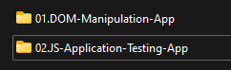
- Go to the JS Application Testing app folder and delete the "node_modules" folder:
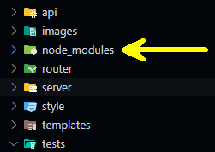
- Archive the folder that contains both applications and your solutions.
- Upload the archive to the SoftUni website in the course section for your exam.

- DOM Manipulation

window.addEventListener("load", solve);

function solve() {

// step 1 - elements to get values from input fields
const customerNameInput = document.getElementById("customer-name");
const baseChoiceElement = document.getElementById("base-choice");
const fruitChoiceElement = document.getElementById("fruit-choice");
const sweetenerAmountElement = document.getElementById("sweetener-amount");

// step 2 - elements to display the preview of the smoothie
const previewNameElement = document.getElementById("preview-name");
const previewBaseElement = document.getElementById("preview-base");
const previewFruitElement = document.getElementById("preview-fruit");
const previewSweetenerElement = document.getElementById("preview-sweetener");

// containers to show/hide
const OrderPreviewContainer = document.getElementById("order-preview");
const orderSuccessContainer = document.getElementById("order-success");

// step 3 - button to submit the order
const customizeSmoothieButton = document.getElementById("order-btn");

// step 4 - event listener for the button
customizeSmoothieButton.addEventListener("click", onCustomize)

function onCustomize(event) {
event.preventDefault();

// step 5 - check if all fields are filled
const allFieldsFilled = customerNameInput.value === '' || baseChoiceElement.value === '' || fruitChoiceElement.value === '' || sweetenerAmountElement.value === '';

if (allFieldsFilled) {
return;
}

// step 6 - display the preview of the smoothie
previewNameElement.textContent = customerNameInput.value;
previewBaseElement.textContent = baseChoiceElement.value;
previewFruitElement.textContent = fruitChoiceElement.value;
previewSweetenerElement.textContent = sweetenerAmountElement.value;

// step 7 - show the order preview container and disable the button
OrderPreviewContainer.style.display = "block";
customizeSmoothieButton.disabled = true;

// step 8 - reset the input fields
customerNameInput.value = '';
baseChoiceElement.value = '';
fruitChoiceElement.value = '';
sweetenerAmountElement.value = '';
}

// step 9 - button to edit the order
const editButtonElement = document.getElementById("edit-btn");

// step 10 - event listener for the edit button
editButtonElement.addEventListener("click", onEdit);

function onEdit() {

// step 11 - populate the input fields with the preview values
customerNameInput.value = previewNameElement.textContent;
baseChoiceElement.value = previewBaseElement.textContent;
fruitChoiceElement.value = previewFruitElement.textContent;
sweetenerAmountElement.value = previewSweetenerElement.textContent;

// step 12 - hide the order preview container and enable the button
OrderPreviewContainer.style.display = "none";
customizeSmoothieButton.disabled = false;
}

// step 13 - button to confirm the order
const confirmButtonElement = document.getElementById("confirm-btn");

// step 14 - event listener for the confirm button
confirmButtonElement.addEventListener("click", onConfirm);

function onConfirm() {
// step 15 - hide the order preview container and show the order success container
OrderPreviewContainer.style.display = "none";
orderSuccessContainer.style.display = "block";
}

// step 16 - button to go back to the order form
const backButtonElement = document.getElementById("back-btn");

// step 17 - event listener for the back button
backButtonElement.addEventListener("click", onBack);

function onBack() {

// step 18 - hide the order success container and enable the button
orderSuccessContainer.style.display = "none";
customizeSmoothieButton.disabled = false;
}

}

- JS Application testing

